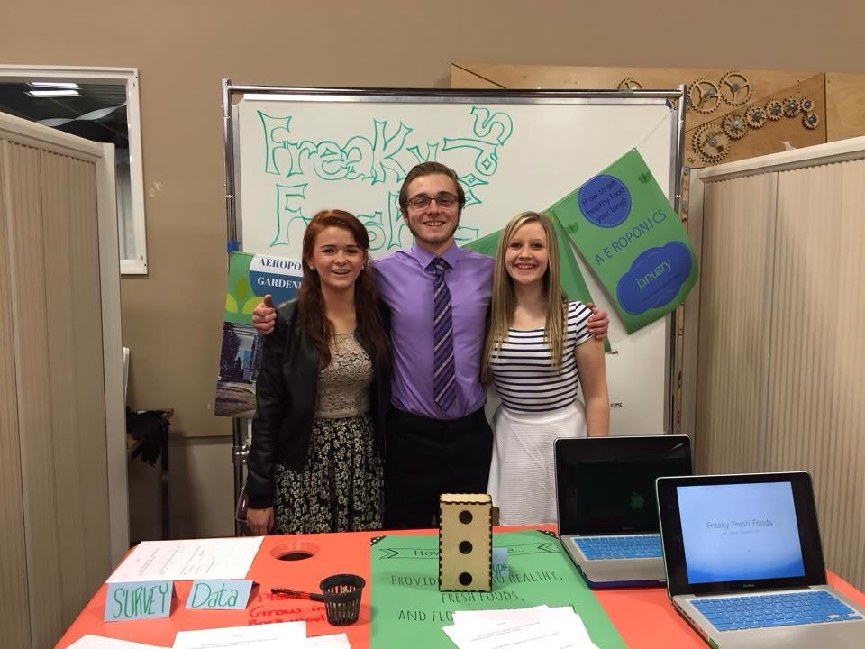
IMPACT HIGHLIGHTS FREAKY FRESH FOODS
Design Team
Chandler, Tori, Alli
Partners
Northwest seed & pet, Home Depot,
Timeline
12 weeks
Location
Spokane, Washington Many people struggle with eating healthy and having it accessible. There is a new law in place in multiple states that requires all “Organic” food to be labeled. However there is many different ways around this law lets take meat for example; if your eggs are considered “organic” and “gmo free” they can get around that by feeding the chickens food that is genetically modified and it still effects the eggs, But they can charge more for the eggs and have them considered gmo free according to the state. The number 1 leading cause of death in the United States is cardiovascular disease so Freaky Fresh Foods saw an amazing opportunity to help people overcome obesity by creating Garden Wall that consumers will have access to year-round.
THE OUTCOME
After multiple design ideas and different building techniques Freaky Fresh Foods finally had a stable unique design that will forever be a part of the new generation helping change others lives.
THE PROCESS
_____________
Inspiration
To gain empathy in the Inspiration phase Freaky Fresh Foods first made a group with Tori, Chandler, and Alli. We when where able to come up with a problem that needed to be solved in a way that can be understood and could help people in their everyday life. We began to notice that people are unhealthy. Right off the bat we knew that was our problem and we came up with a How Might We statement. Which is: How might we provide access to healthy fresh foods. Freaky Fresh Foods clarified who our user was and understood what their needs where by setting up and creating a interview with David Blane owner of Central Food. As Freaky Fresh Foods interviewed him, quickly realized that having everything fresh is crucial to him and growing a garden is what he wants to continue to do and make it bigger. Freaky Fresh Foods started to look into it and quickly realized we wanted to build an Aeropontic System that would grow healthy food, to satisfy people with the needs and wants as David. Then started to interview other people and interviewed another person about his garden house and he gave us a tour and a look into what it would be like to own and run something as big as that. What had to be understood multiple people’s needs for what they consider a healthy lifestyle and that’s what we did for the card sort. Freaky Fresh Foods had to build a plan and figure out how we where going to fill the needs of David by successfully solving our problem of unhealthy eating habits. Then had to be mapped out what we wanted our System to look like by drawing it out and what it would do and how it would provide fresh foods. Freaky Fresh Foods is aiming towards restaurant owners and locally owned grocery stores.
__________
Ideation
From the beginning our team had envisioned a basic problem we wanted to solve which was, how can anyone in any sort of living situation eat healthy and have access year around to healthy, fresh produce? After taking multiple surveys we found that many people of any age group would love to eat better and eat fresh foods if they had the choice. The problem is that many foods are seasonal and so we do not have constant access to all the fruits and vegetables that we would like. Many people that we had the chance to talk to expressed to us that they would love to garden if they had the time and space but they just don’t. Great deals of people live in apartments or small homes that doesn’t allow the space to have a garden. But even with a garden there are still an abundance of negatives to having a traditional garden. So much time has to be put into it and you still don’t have produce year around. That gave us more incentive to create a product everyone could use. We had many different ideas anywhere from having a farmers market every mile, to hydroponic systems to traditional gardening in soil. Although, every solution we came across had more negatives about it rather than benefits. Products like our Aeroponics system may have versions like it already but they are all very over priced and so average people are not able to purchase these because of their budget. Eventually we came to the product that we have today, an Aeroponics Wall.
_____________
Implementation
By the end of the implementation phase the team members of Freaky Fresh Foods got together and collaborated to come up with a solution advertise and promote the aeroponic gardening wall. The team came up with the idea to hand out flyers to people on the streets of Spokane, Washington. The team also decided to speak with local businesses such as restaurants, coffee shops, and gardening supply stores to hang up flyers within the businesses to help promote Freaky Fresh Foods and its products.

Method Spotlight
Rapid Prototyping is useful in so many ways; it gives the user a visual 3D model to interact with. Giving the user something they can interact with gives them a sense of how it’s going to work and what needs to be fixed before its built. With this in mind it cuts down on costs so you only build one final product vs. multiple products. Not only does it help you design it, but it also helps sell the product.
We built 4 prototypes and from there we all went around showing multiple users the product and taking notes on what to change, what they liked, what they thought would work, and what they thought wouldn’t. Then we narrowed it down to the final two and redesigned very descriptive models; went and asked the same questions again, and picked the best. Then we had a final prototype to show the user. When presenting our final prototype to an audience we explained our idea then gave them a visual and it worked to a great advantage having a 3D model for them.
This is the most important process in my mind for the fact that no one is going to want a product they have never seen, or understand to a full. We can explain the model in the same words and 10 different people will think of 10 different designs, so having a visual of what the product will look like gives them all the same idea. With this in mind most people prototype with any and every idea, weather this is drawing an app and having people give feed back, or building a miniature model of something everyone prototypes to receive feedback.

